Experiment 4：Traffic light design experiment
Above we have completed the single lamp control experiment, then we have to do a slightly more complex at the traffic light experiment, in fact, smart friends can see this experiment is the experiment above individual lights is extended to the three color lights, you can realize we simulate the traffic light experiment. We complete this experiment required components in addition to the Arduino controller and the download line also need hardware are as follows:
The red line M5 LED*1
The yellow line M5 LED*1
220Ωresistence *3
Bread board *1
The bread board jump line *1 tie
We can start with the above components.We can according to the above experimental one small light flashes,Here we provide a reference to the schematic, we use the digital 10,7,4, respectively, the interface..
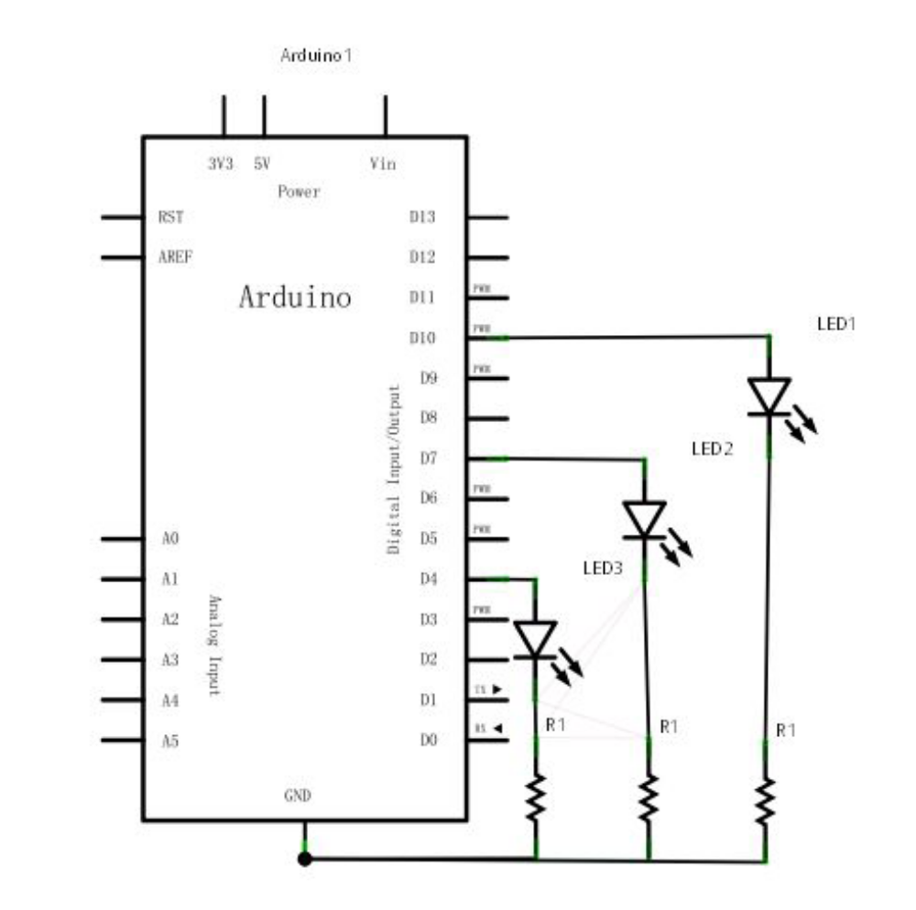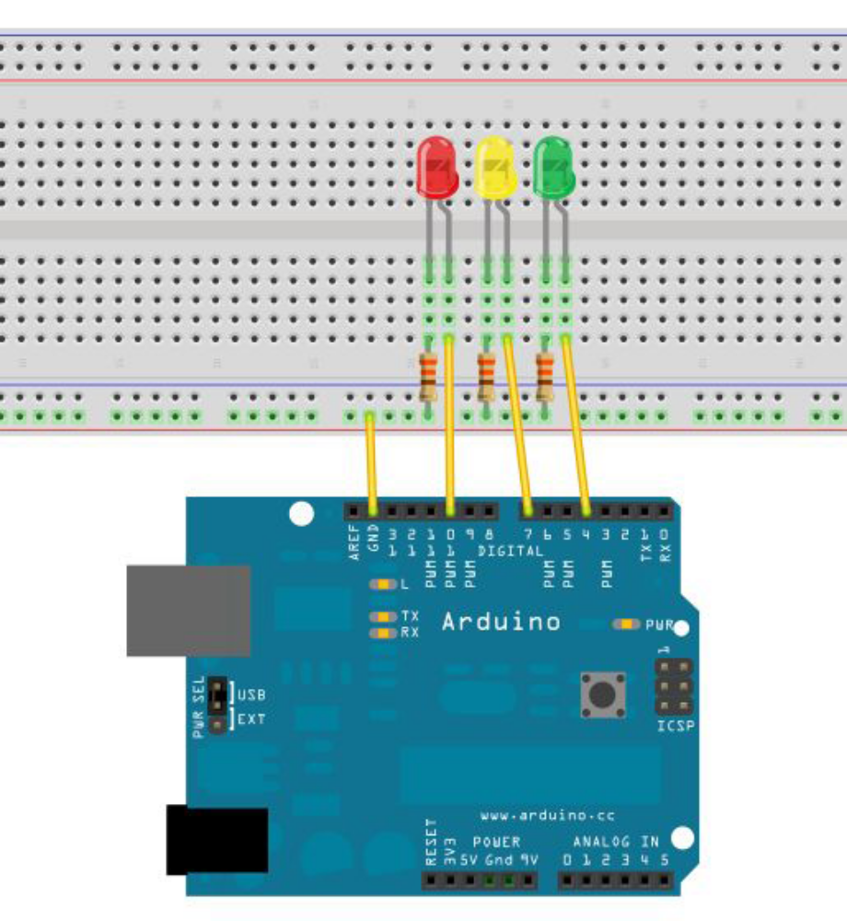
Since it is a simulation of traffic lights, traffic lights flashing red yellow green lights to simulate the real time，We use the delay Arduino () function to control the time delay, relative to the C language is much simpler.
The following is a section of the reference program:
int redled =10; //Define number 8 interface
int yellowled =7; //Define number 7 interface
int greenled =4; //Define number 4 interface
void setup()
{
pinMode(redled, OUTPUT);//The definition of red lights interface for output interface
pinMode(yellowled, OUTPUT); //The definition of yellow lights interface for output interface
pinMode(greenled, OUTPUT); //The definition of green lights interface for output interface}
void loop()
{
digitalWrite(greenled, HIGH);////Light the green light
delay(5000);//delay 5 seconds
digitalWrite(greenled, LOW); //Put out the green light
for(int i=0;i<3;i++)//Flashes alternating three times, flashing effect of yellow light
{
delay(500);//delay 0.5 seconds
digitalWrite(yellowled, HIGH);//Light yellow light
delay(500);//delay 0.5 seconds
digitalWrite(yellowled, LOW);//out yellow light
}
delay(500);//delay 0.5 seconds
digitalWrite(redled, HIGH);//light red light
delay(5000);//delay 0.5 seconds
digitalWrite(redled, LOW);//out red light
}

After the download is complete, we can see our own design and control of the traffic lights.。
Note: This design is very similar to the light water lamp, not on the picture.
Experimental results: the green light 5 seconds, the green light goes out, the yellow light flashes 3 times, the red light 5 seconds, followed by the cycle.
The end of the experiment,
Thank you .

